$oftware ¢orp

Software Requirement Specification

for

ParkPilot
(Smart Parking Platform)

Version 1.0

Prepared by Jason Montemayor

University of Houston – College of Engineering

Computer Information Systems

CIS 4374 Information System Project Management

September 10, 2026

Table of Contents

1. Existing Software Landscape
1.1 Existing Parking Applications
1.2 ParkPilot Differentiation
2. Vision and Scope
2.1 Project Acquisition
2.2 Company Introduction
2.3 Project Overview
3. Software Requirements Specification (SRS)
3.1 Use Cases

Software Requirements Specification
ParkPilot
Version 1.0

1. Existing Software Landscape

1.1 Existing Parking Applications:
This purpose of this document will be to research existing parking services that are similar to ParkPilot. SpotHero will be used as the primary competitor, along with one or two additional parking platforms for comparison. The research will examine the features offered by these applications and identify ideas that may influence the development of ParkPilot.

1.2 ParkPilot Differentiation:
This section will explain how ParkPilot will differ from existing parking applications. Rather than simply duplicating an existing platform, ParkPilot will identify opportunities to improve the parking experience for drivers and parking operators, with a focus on the Houston area. ParkPilot will differentiate itself from existing parking applications by providing a more complete and locally focused parking experience for the Houston area. The platform will combine real-time parking availability, reservations, digital payments, navigation, and parking facility information on one application. Users will be able to compare locations based on price, distance, availability, and amenities, while features such as QR-code or license-plate detection, parking reminders, and reservation extensions will make parking more convenient. ParkPilot will also provide parking operators with tools to monitor occupancy, pricing, reservations, and facility usage.

2. Vision and Scope
2.1 Project Acquisition:
The ParkPilot project was acquired by $oftware ¢orp. after identifying a need for a more efficient parking solution in the Houston metropolitan area. Drivers frequently experience difficulty locating available and affordable parking, particularly in high-traffic areas. $oftware ¢orp. will develop ParkPilot to provide drivers and parking operators with a centralized platform for locating, reserving, managing, and paying for parking.

2.2 Company Introduction:
$oftware ¢orp. is a software development company that specializes in creating technology solutions designed to improve everyday business operations. The company develops web and mobile applications with a focus on usability, reliability, and efficiency. For the ParkPilot project, $oftware ¢orp. will oversee the planning, development, testing, and implementation of the smart parking platform.
2.3 Project Overview:
ParkPilot is a smart parking platform designed to help drivers locate available parking spaces, compare parking options, reserve spaces, make digital payments, and navigate participating parking facilities. The platform will be available through both web and mobile applications and will initially focus on the Houston metropolitan area. Parking operators will also have access to management tools for monitoring occupancy, reservations, pricing, and parking activity.

3. Software Requirements Specification (SRS)
3.1 Use Cases
Use Case 1
Title: Register Driver Account
Actor: Driver
Precondition: User does not already have a ParkPilot account.
Steps:
1. User selects “Create Account.”
2. User enters their name, email address, phone number, and password.
3. User reviews the entered information.
4. User selects “Create Account.”
5. ParkPilot creates the new driver account.
Postcondition: Driver account is created and available for use.

Use Case 2
Title: Log In and Authenticate User
Actor: Driver or Parking Operator
Precondition: User has a registered ParkPilot account.
Steps:
1. User selects “Log In.”
2. User enters their email address and password.
3. User submits the login information.
4. ParkPilot verifies the user’s credentials.
5. User is granted access to the appropriate account.
Postcondition: User is authenticated and logged into ParkPilot.

Use Case 3
Title: Register Vehicle
Actor: Driver
Precondition: Driver is logged into ParkPilot.
Steps:
1. Driver selects “My Vehicles.”
2. Driver selects “Add Vehicle.”
3. Driver enters the vehicle license plate, make, model, and color.
4. Driver reviews the vehicle information.
5. Driver selects “Save Vehicle.”
Postcondition: Vehicle is registered to the driver’s account.

Use Case 4
Title: Register Payment Method
Actor: Driver
Precondition: Driver is logged into ParkPilot.
Steps:
1. Driver selects “Payment Methods.”
2. Driver selects “Add Payment Method.”
3. Driver enters the required payment information.
4. ParkPilot validates the payment information.
5. Driver saves the payment method.
Postcondition: Payment method is securely associated with the driver’s account.

Use Case 5
Title: Find Parking Garage
Actor: Driver
Precondition: Driver has access to the ParkPilot application.
Steps:
1. Driver enters a destination or location.
2. Driver enters the desired parking date and time.
3. ParkPilot searches participating parking facilities.
4. ParkPilot displays available garages on an interactive map.
5. Driver selects a garage to view additional information.
Postcondition: Driver is shown available parking options near the selected destination.

Use Case 6
Title: Reserve Parking Space
Actor: Driver
Precondition: Driver is logged in and has selected an available parking facility.
Steps:
1. Driver selects the desired garage.
2. Driver selects the parking date and time.
3. Driver selects a registered vehicle.
4. ParkPilot displays the reservation details and price.
5. Driver confirms the reservation.
Postcondition: A parking space is reserved for the driver.

Use Case 7
Title: Pay for Parking Reservation
Actor: Driver
Precondition: Driver has selected a parking reservation and has a valid payment method.
Steps:
1. Driver reviews the reservation cost.
2. Driver selects a registered payment method.
3. Driver selects “Pay.”
4. ParkPilot processes the payment.
5. ParkPilot displays a payment confirmation.
Postcondition: Parking reservation is paid and confirmed.

Use Case 8
Title: Navigate to Parking Garage
Actor: Driver
Precondition: Driver has selected or reserved a parking facility.
Steps:
1. Driver selects “Directions.”
2. ParkPilot sends the garage location to the navigation service.
3. Navigation directions are displayed.
4. Driver follows the directions to the parking facility.
Postcondition: Driver receives navigation assistance to the selected garage.
Use Case 9
Title: Check In to Parking Facility
Actor: Driver
Precondition: Driver has an active reservation at the parking facility.
Steps:
1. Driver arrives at the reserved parking facility.
2. Driver scans the ParkPilot QR code or uses the registered license plate.
3. ParkPilot verifies the active reservation.
4. The parking facility grants the driver access.
5. ParkPilot records the driver’s arrival.
Postcondition: Driver is successfully checked into the parking facility.
Use Case 10
Title: Extend Parking Time
Actor: Driver
Precondition: Driver has an active parking reservation and additional time is available.
Steps:
1. Driver opens the active reservation.
2. Driver selects “Extend Parking.”
3. Driver selects a new ending time.
4. ParkPilot displays any additional cost.
5. Driver confirms and pays for the extension.
Postcondition: Parking reservation is extended to the new ending time.

Use Case 11
Title: Cancel Parking Reservation
Actor: Driver
Precondition: Driver has an active reservation that is eligible for cancellation.
Steps:
1. Driver opens the reservation.
2. Driver selects “Cancel Reservation.”
3. ParkPilot displays the cancellation information.
4. Driver confirms the cancellation.
5. ParkPilot cancels the reservation and processes any applicable refund.
Postcondition: Reservation is canceled and the parking space becomes available again.

Use Case 12
Title: View Reservation History and Receipt
Actor: Driver
Precondition: Driver is logged into ParkPilot and has completed at least one reservation.
Steps:
1. Driver selects “Reservation History.”
2. ParkPilot displays current and previous reservations.
3. Driver selects a reservation.
4. ParkPilot displays the reservation details and payment information.
5. Driver views or downloads the receipt.
Postcondition: Driver can review previous parking reservations and receipts.

Use Case 13
Title: Register Parking Operator Account
Actor: Parking Operator
Precondition: Parking operator does not already have a ParkPilot operator account.
Steps:
1. Operator selects “Register as Parking Operator.”
2. Operator enters business and contact information.
3. Operator creates login credentials.
4. Operator submits the registration.
5. ParkPilot creates the operator account.
Postcondition: Parking operator account is created and can be used to manage parking facilities.

Use Case 14
Title: Manage Parking Facility
Actor: Parking Operator
Precondition: Operator is logged into an approved ParkPilot operator account.
Steps:
1. Operator opens the management dashboard.
2. Operator selects a parking facility.
3. Operator updates parking capacity, availability, hours, amenities, or pricing.
4. Operator reviews the changes.
5. Operator saves the updated facility information.
Postcondition: Updated parking facility information is available to ParkPilot users.

Use Case 15
Title: View Parking Occupancy and Analytics
Actor: Parking Operator
Precondition: Operator is logged in and manages at least one parking facility.
Steps:
1. Operator opens the management dashboard.
2. Operator selects “Reports and Analytics.”
3. Operator selects a parking facility and reporting period.
4. ParkPilot displays occupancy, reservations, revenue, and usage information.
5. Operator reviews the report.
Postcondition: Parking operator can review facility performance and parking activity.

4. Work Breakdown Structure (WBS)
ParkPilot Work Breakdown Structure
1.0 User Authentication
1.1 User Registration
1.1.1 Driver Registration
1.1.2 Operator Registration
1.2 Login Authentication
1.2.1 Credential Verification
1.2.2 Password Recovery
2.0 User & Operator Profile Setup
2.1 Driver Profile
2.1.1 Driver’s Personal Information
2.1.2 Driver’s Contact Information
2.2 Driver’s Vehicle Management
2.2.1 Driver’s Vehicle Registration
2.2.2 Driver’s Vehicle Information Update
2.3 Driver’s Payment Setup
2.3.1 Driver’s Payment Method Registration
2.3.2 Driver’s Payment Method Management
3.0 Parking Management
3.1 Garage Search
3.1.1 Location Search
3.1.2 Available Garage Display
3.2 Parking Reservation
3.2.1 Reserve Parking Space
3.2.2 Extend Parking Time
3.2.3 Cancel Reservation
3.3 Navigation
3.3.1 Garage Location Map
3.3.2 Navigation to Garage
4.0 Operator Dashboard
4.1 Garage Management
4.1.1 Add Garage
4.1.2 Edit Garage
4.1.3 Remove Garage
4.2 Parking Availability
4.2.1 Monitor Occupancy
4.2.2 Update Availability
4.3 Pricing Management
4.3.1 Set Parking Rates
4.3.2 Update Parking Rates
5.0 Payment Processing
5.1 Parking Payment
5.1.1 Calculate Parking Cost
5.1.2 Process Payment
5.2 Payment Record
5.2.1 Generate Receipt
5.2.2 View Payment History
6.0 Reporting & Analytics
6.1 Occupancy Reporting
6.1.1 Occupancy Data
6.1.2 Occupancy Graph
6.2 Reservation Reporting
6.2.1 Reservation History
6.2.2 Garage Usage Data
6.3 Financial Reporting
6.3.1 Revenue Reports
6.3.2 Financial Graphs
5. Gantt Graph
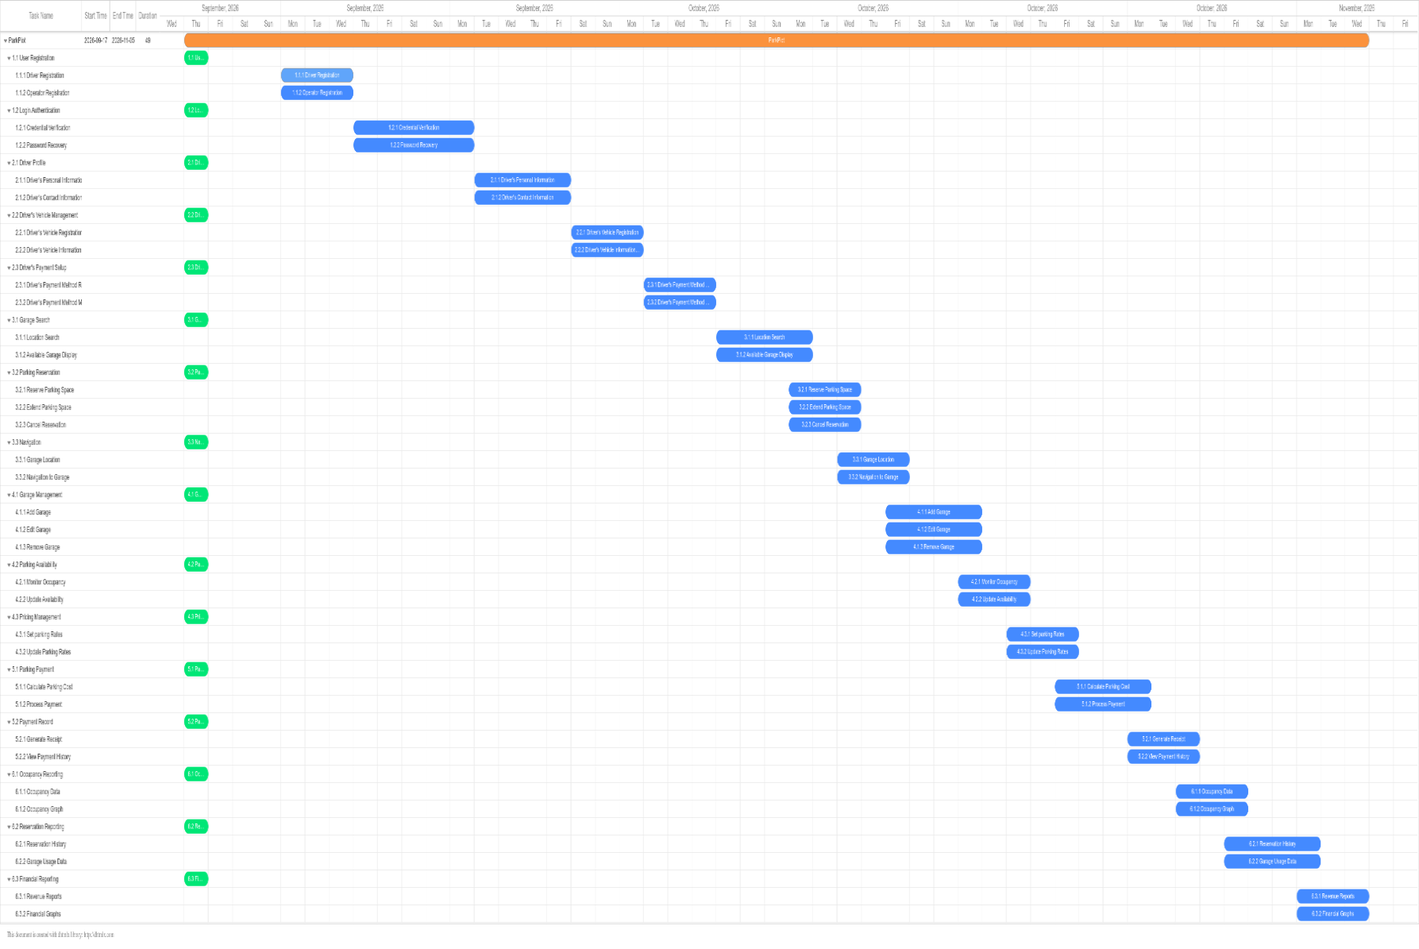

6. Backlog Board Sprint 1Go
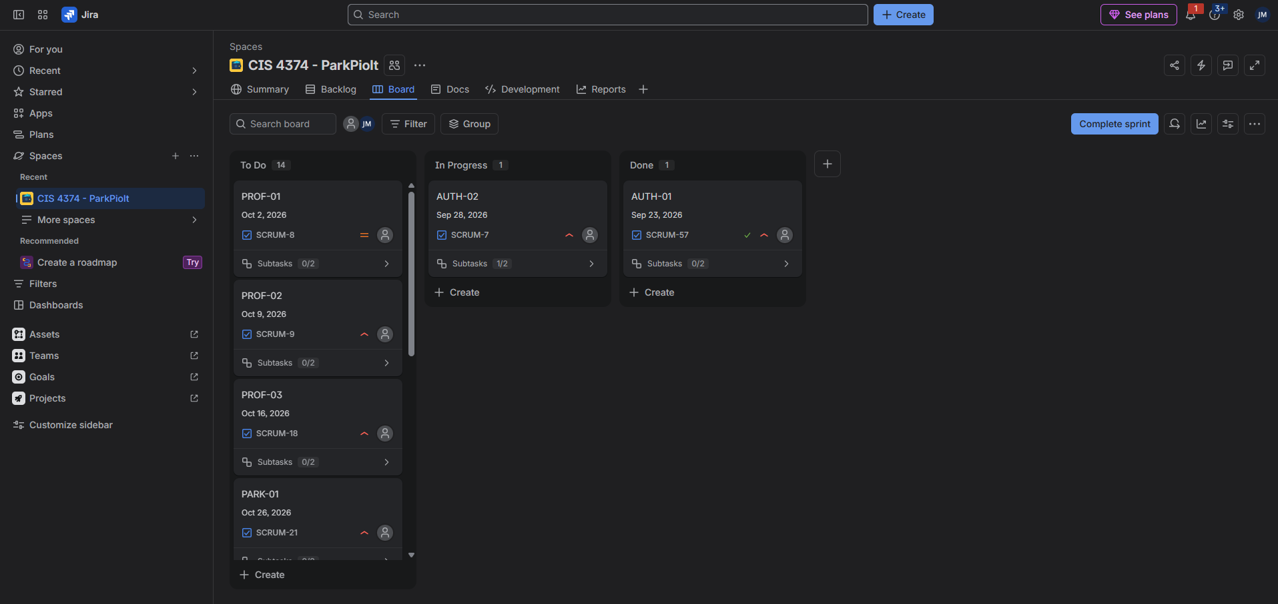

ParkPilot Risk Identification
ID | Category | Risk
Tech-01 | Technical | Mapping Navigation API may fail or provide inaccurate location information.
Tech-02 | Technical | Payment processing integration may fail or experience transaction errors
Tech-03 | Technical | Real time parking availability may display inaccurate or outdated garage occupancy information.
Tech-04 | Technical | Security vulnerabilities may expose user account, vehicle, or payment information.
Schd-01 | Schedule | Delays in completing one WBS deliverable may delay dependent backlog tasks.
Schd-02 | Schedule | Third party mapping or payment integration may take longer than estimated.
Schd-03 | Schedule | Testing may identify defects that require additional development and rework.
Schd-04 | Schedule | Changes to requirements may cause tasks to exceed their planned Gnatt chart dates.
Fisc-01 | Financial | Third party mapping/API service costs may exceed estimates as system usage increases.
Fisc-02 | Financial | Payment processing fees may be higher than originally estimated.
Fisc-03 | Financial | Additional development or testing caused by defects may increase project cost.
Fisc-04 | Financial | Cloud hosting, databases, or storage costs may exceed projected operating costs.
Peop-01 | People | A development team member may become unavailable or leave the project.
Peop-02 | People | Team members may lack experience with required APIs or technologies.
Peop-03 | People | Poor communication between development teams may cause integration problems.
Peop-04 | People | Disagreements over requirements or priorities may delay development decisions.

ParkPilot Risk Register
ID | Description | Probability | Impact | Owner | Response Strategy | Status / Notes
Tech-01 | Mapping / Navigation API failure or inaccurate location data. | Moderate | Major | Team 4 | Mitigate | Test API integration and maintain error handling and fallback procedures.
Tech-02 | Payment integration failure or transaction errors. | Moderate | Major | Team 5 | Mitigate | Test payment transactions before deployment and maintain transaction logs.
Tech-03 | Security vulnerability exposes user or payment information | Low | Catastrophic | Team 6 | Mitigate | Conduct security testing and enforce authentication and data protection controls.
Schd-01 | Delay in one WBS deliverable affects dependent task. | Moderate | Major | Project Manager | Mitigate | Monitor Gantt milestones and adjust resources when delays occur.
Schd-02 | Testing discovers defects requiring additional rework | High | Moderate | Team 6 | Mitigate | Conduct testing throughout development rather than waiting until completion.
Schd-03 | Third-party API integration takes longer than estimated | Moderate | Moderate | Team 4 | Mitigate | Begin integration testing early and monitor API dependencies.
Fisc-01 | Mapping/API service costs exceed estimates | Low | Moderate | Project Manager | Accept | Monitor API usage and associated service costs.
Fisc-02 | Payment processing fees exceed estimates | Low | Moderate | Team 5 | Mitigate | Monitor transaction fees and evaluate payment service options.
Fisc-03 | Development and testing rework increases project costs | Moderate | Moderate | Team 3 | Mitigate | Use code reviews and early testing to reduce costly rework.
Peop-01 | Team lacks experience with required technology | Moderate | Moderate | Team 1 | Mitigate | Provide technical training and assign experienced members to complex tasks.
Peop-02 | Poor communication between teams causes integration problems | Moderate | Major | Project Manager | Mitigate | Hold regular cross-team meetings and maintain shared project documentation.
Peop-03 | Team disagreements delay development decisions | Low | Moderate | Project Manager | Mitigate | Escalate unresolved decisions to the project manager and document decisions.

ParkPilot Communication Plan
Team / Audience | Meeting | Cadence | Purpose | Reporting Method
Team 1 | Mobile Development Stand-up | Daily | Review mobile tasks, progress, and upcoming work. | Kanban board / team chat
Team 2 | Web Development Stand-Up | Daily | Review operator web interface tasks and blockers | Kanban board / team chat
Team 3 | Backend/API Stand-Up | Daily | Review APIs, authentication, reservations, and database work | Kanban board / team chat
Team 4 | Mapping & Location Stand-Up | Daily | Review map, location search, navigation, and API integration | Kanban board / team chat
Team 5 | Payment Integration Stand-Up | Daily | Review payment processing and transaction integration | Kanban board / team chat
Team 6 | QA & Testing Stand-Up | Daily | Review testing progress, defects, and resolved issues | Test/defect report and Kanban board
Team Leads | Project Progress Meeting | Weekly | Review schedule, dependencies, risks, and cross-team issues | Gantt chart, Risk Register, and status report
Project Managers | Project Status Meeting | Biweekly | Review overall project progress, major risks, milestones, and decisions | Project dashboard and progress report
Project Team & Stakeholders | Sprint Review | Monthly | Demonstrate completed functionality and review overall progress | Software demonstration and presentation

